Requirement Analysis - “Cicero”
Montpellier RIO Imaging

Responsible: Alexandre Granier
Contact: 04 34 35 95 19 / alexandre.granier@mri.cnrs.fr

Table of Contents
1 Virtual file system structure 5

Illustration Index
figure 1: Folder caramel is a root folder, its parent is /home folder 5
figure 2: Folder 10.06.2011 11:43 is a folder shared by granier and moved by another user. 5
figure 3: user caramel see granier's share folder. 6

Changes
Version 0.1 |  | first version

Virtual file system structure
In Cicero, users manage their images using a file explorer like interface. There are folders and files of different types (image, text-document, …). Users can create folders and copy or move files within the folders. A user can share a folder with other users. The other users can access the files in the shared folder.

Root folders
There are two types of root folders in cicero:
- root folders that the user has created himself.
- If a user A shares a folder with the user B, the user B sees a folder with the name of the user A on the toplevel. This folder contains the folders.that the user A has shared with the user B.

Folder-creation at first login
The first time a user logs in to the web-interface he has no folders. A toplevel folder with the name of his login is automatically created. The same applies if the first action of the user in the system is the upload of an image.

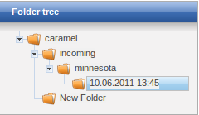figure 1: Folder caramel is a root folder, its parent is /home folder

Shared folder
If a user shares some of his folder with another user, this user will see appear a new root folder with the icon of a user which will contain the shared folders.
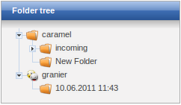figure 2: user caramel see granier's share folder.

User interface for file sharing
Sharing is possible by right-clicking on the folder tree and choosing share.
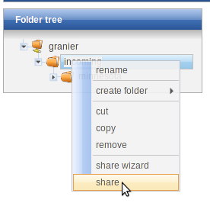figure 3: Contextual menu
The user interface present a two side list field which contain groups to share with.

If no group exists
User needs to create group before performing share.

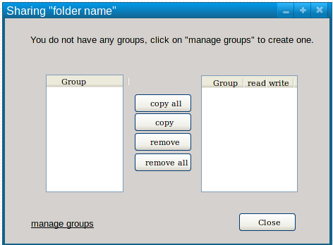figure 4: Share dialog with no group

If group already exists
The group have to be moved on the right side before applying any right.
The right side of the list shuffle allows to set rights on current folder. By clicking on checkbox, rights are immediately applied on folder. By clicking on the “apply on subfolders” button, the same rights are applied on all sub-directories recursively.
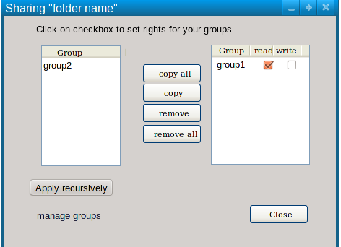figure 5: Share dialog with existing groups

Managing groups
By clicking on the manage group link, user can add, remove group and manage users.
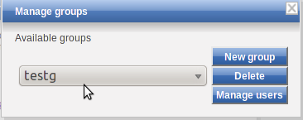Illustration 1: Interface to manage groups

By clicking on Manage users, users can add or remove users in a group.

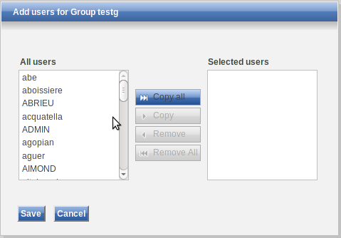Illustration 2: Adding users to a group

