Requirement Analysis
Montpellier RIO Imaging

Responsible: Alexandre Granier
Contact: 04 34 35 95 19 / alexandre.granier@mri.cnrs.fr

Table of Contents
1 Viewer 2
1.1 Context 2
1.2 Accessing the viewer 2
1.3 Viewer : main windows 3
1.3.1 Single image 3
1.3.2 Image with z-Index 4
1.3.3 Image with z-Index and time points 4
1.3.4 Images with chanels 5
1.3.5 Big image 6
2 Special formats features 7
Index des illustrations
Illustration 1: Contextual menu to call viewer 3
Illustration 2: Display submenu 3
Illustration 3: Viewer : simple image 4
Illustration 4: Viewer with small image and z-index dimension 4
Illustration 5: Viewer 4D 5
Illustration 6: Viewer : image with channels 5
Illustration 7: Viewer : channels selection 6
Illustration 8: viewer : big image visualization 6
Illustration 9: viewer : minimal zoom on big image 7

Changes
Version 1 | 23/04/12 | Initial version

Viewer

Context
WIDE as an image database must provide a function to browse all dimensions of an image, conveniently and efficiently. This browser will ba called the “viewer” and will be accessible on the web interface by double-clicking on an image (file or thumbnail).
A specific interface will allow to to go through temporal, zIndex and channel dimensions.
In case of very large images, a panorama navigation must be enabled and permit to zoom in or zoom out the image.

Accessing the viewer
To launch the viewer, an user double-click on a file or right click and choose “view”.
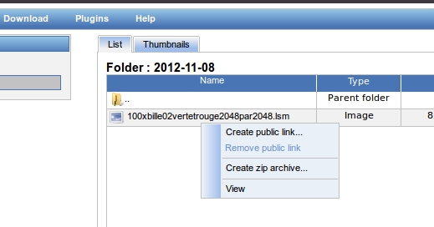Illustration 1: Contextual menu to call viewer
A menu must be add in the “Diplay” menu.
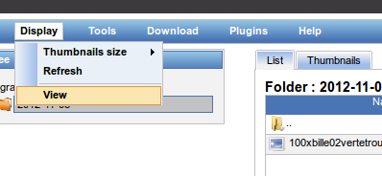Illustration 2: Display submenu

Viewer : main windows
Once the viewer has been launch, a new window appears that show the first dimension of the image. Some elements are always present, others depends on the image.

Single image
In the case of a only bi-dimensional image (x, y), the viewer will allow to zoomify using the scroll mouse or by clicking on plus / minus icons. A 1:1 icon allow to return to the non zoom size.
A thumbnail allow to show the entire image and the zone the viewer is rendering.
A panel shows general information on image.
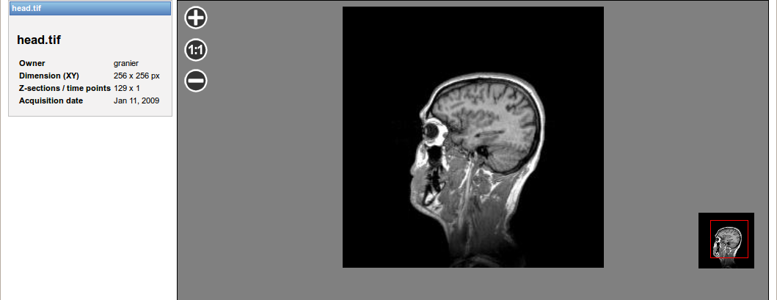Illustration 3: Viewer : simple image

Image with z-Index
A slider allow to browse the z-index dimension.

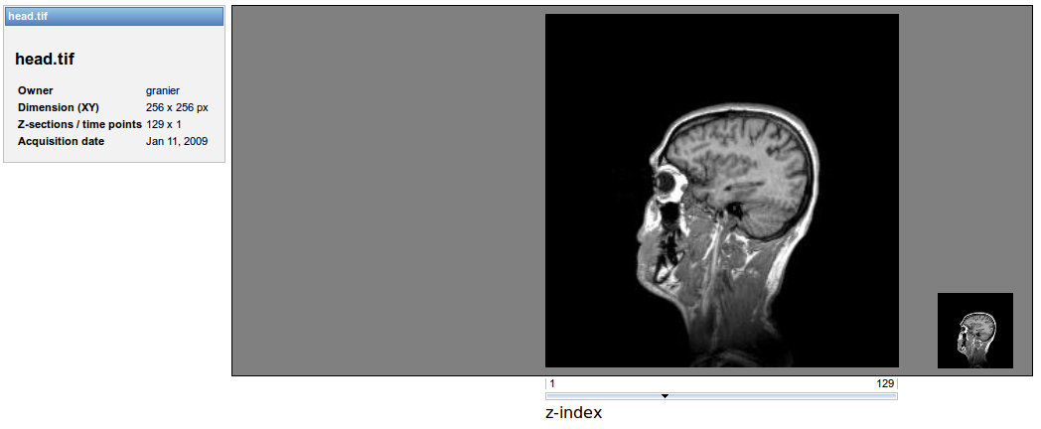Illustration 4: Viewer with small image and z-index dimension

Image with z-Index and time points
A vertical slider allow to browse the time dimension.

Images with channels
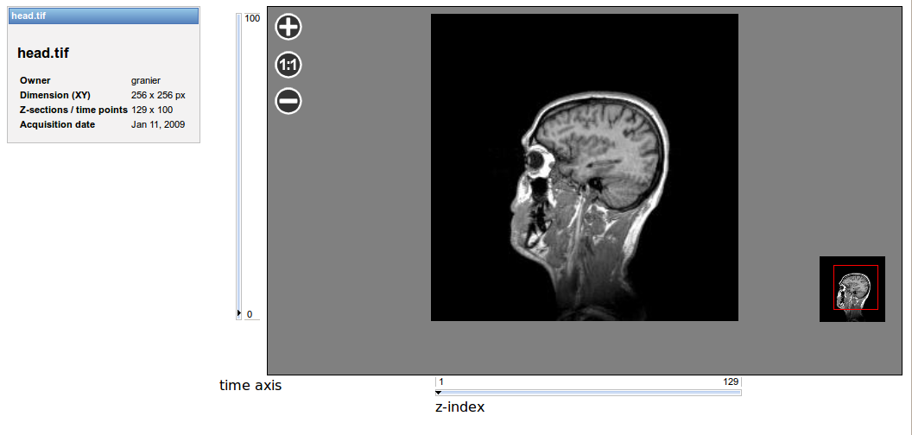Illustration 5: Viewer 4D
This feature allow to browse channels in image that host an image per channel. The RGB decomposition of an image is not possible at the moment.
In this case, checkboxes are available to turn on / off channels.
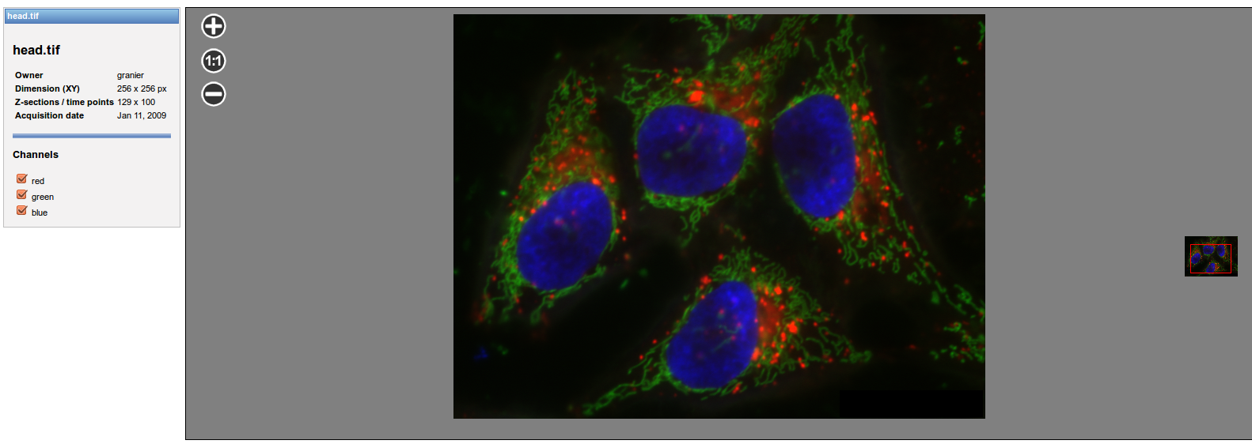Illustration 6: Viewer : image with channels
Turning off a channel can be achieve by check – uncheck a checkbox.
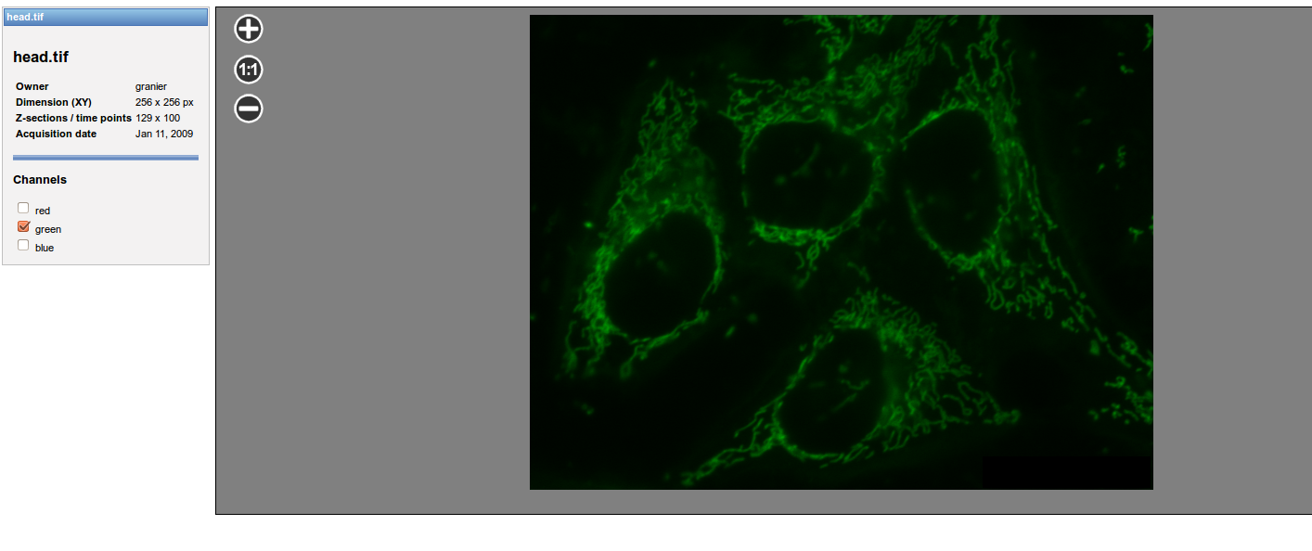Illustration 7: Viewer : channels selection
A checkbok button allow to display all channels in the viewer.

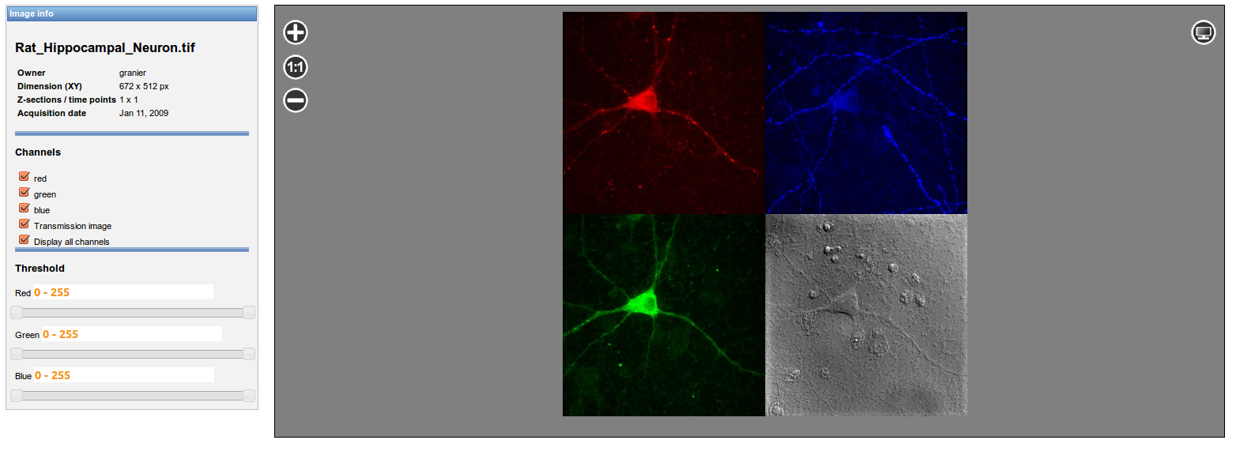Illustration 8: Splitting channels

Big image
Some device produce very high resolution images (e.g slide scanner).
It is necessary to allow viewing big images (> 1Mpixels) rapidly.
Paning the image can be achieved by mouse motion (drag and drop).
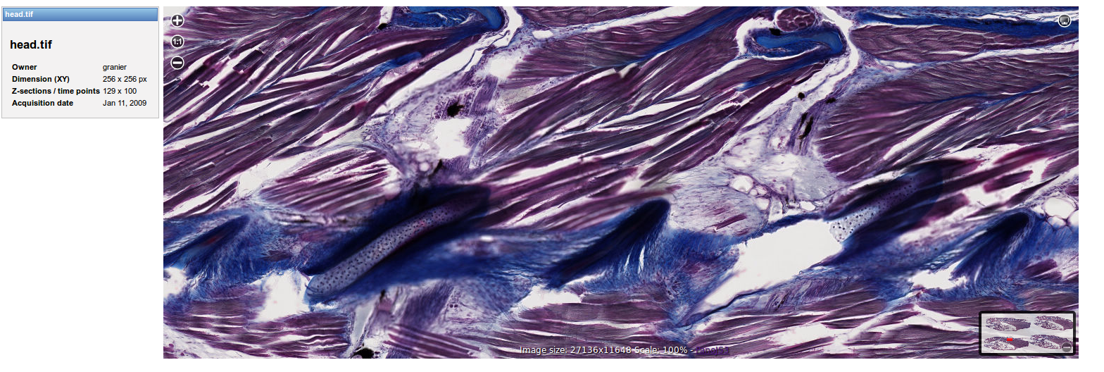Illustration 9: viewer : big image visualization
Zooming can be achieved by clicking on the plus an minus icon or by central mouse button.
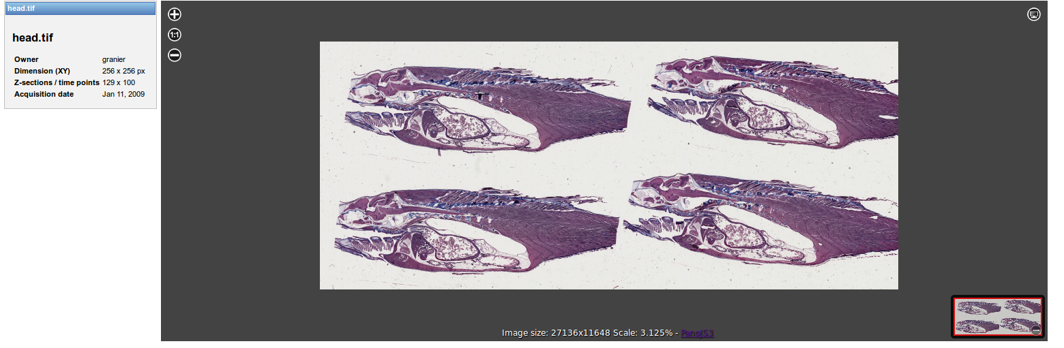Illustration 10: viewer : minimal zoom on big image

Threshold ajustment

Luminosity and contrast

Manual adjustment
Threshold adjustment is possible for every channel in the image. It can be performed using a ranged slider availble on the left window.
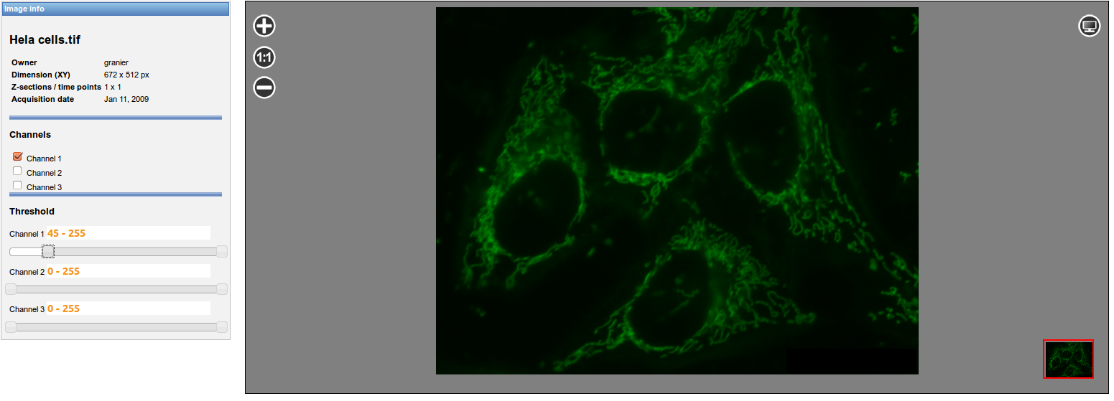Illustration 11: threshold adjustment

Auto adjustment

Special formats features

