Solution 02 - Basic tools 1

Solution 2.1: Pixel information, zooming and scrolling
- The maximum zoom is 3200%, the minimum zoom 3.1%
- The grey-value of the pixel with the coordinates x=549 and y=305 is 199. The grey-value of the pixel with the coordinates x=58 and y=246 is 197.
- width = 550 pixel, height = 515 pixel, type = 8-bit, size = 327K.
- x-coordinates become bigger from left to right, y-coordinates from top to bottom. This is a coordinate-system of the form:
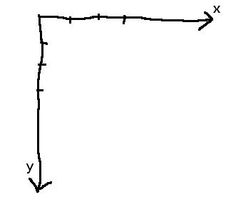Figure 1: The coordinate system - y grows from top to bottom.
- y-coordiantes become now bigger from bottom to top. This is a coordinate-system of the form:
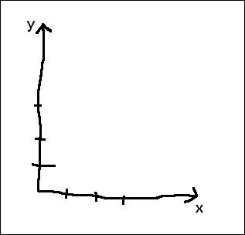Figure 2: The coordinate system with inverted y-coordinates.

Solution 2.2: Area selection tools

  - Shift - Selection is constrained to a square
  - Alt - Width / height are changed with arrow keys one pixel at a time
  - Ctrl - Selection is resized around the center
  - Ctrl Alt - Current aspect ratio is maintained while resizing

- Image>Crop crops the image to the selections bounding box, cutting away everything outside of the bounding box. Image>Duplicate creates a new image with the content of the selections bounding box.

Solution 2.3: Measuring and the results table

- New measurements are always added to the table names Results. If no table with this name is opened, a new one is created and shown.
- See b)
- Mean, std-dev, min and max can be found in the summarized results-table, the mode can be found in the distribution image.
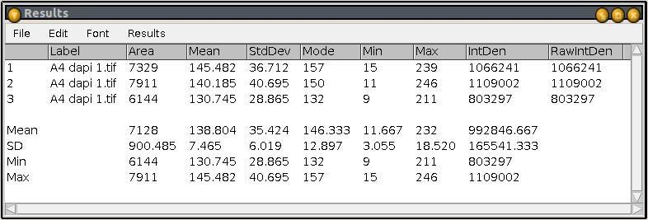Figure 3: Results table with summerized values.
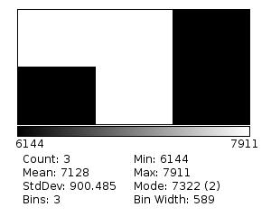Figure 4: The distribution of the area values.
Solution 2.4: Line selection tools

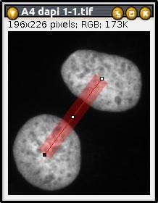Figure 5: Measuring the distance between two nuclei.

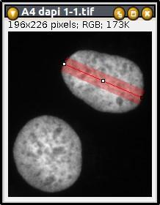Figure 6: Measuring the diameter of a nucleus.

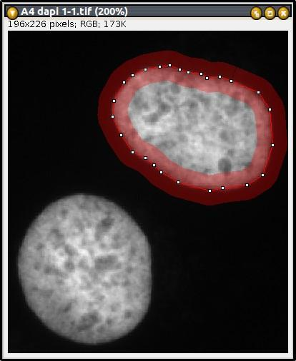Figure 7: Measuring the perimeter with the segmented line tool.

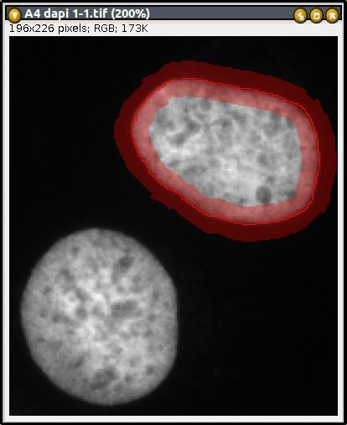Figure 8: Measuring the perimeter with the freehand line tool.

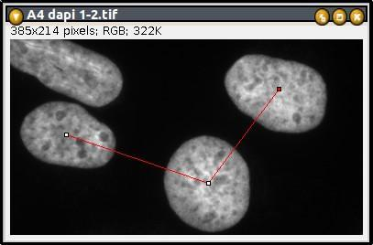Figure 9: Measuring the angle between the center points of three nuclei.

Solution 2.5: Profile plots
- Depending on the display settings the object may appear bigger or smaller. In the profile plot the background baseline is often good visible and you can measure the diameter above of it.
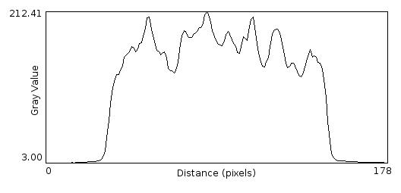Figure 10: An intensity profile of a line across a nucleus.
- The profile is smoother because it is averaged over the line-width.
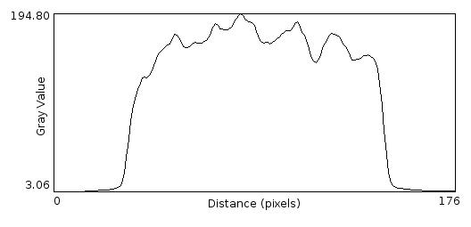Figure 11: The same profile plot as above but with a line-width of 21.
- The plots have different sizes. However they have different scales as well, so that measurements in the plots correspond to distances in the original image. So you should measure the same distance between two corresponding couples of points in the two plots. The properties dialog reveals that the pixel size is different in the two plots.
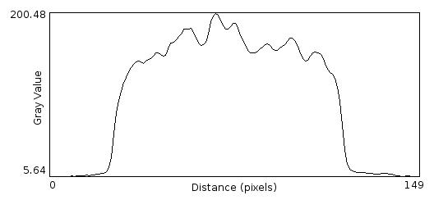Figure 12: Plot with a shorter line.
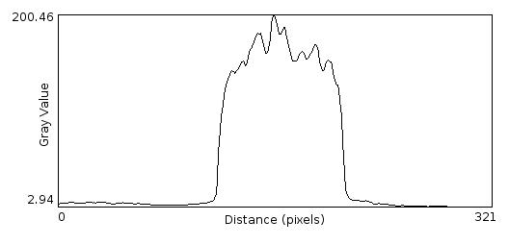Figure 13: Plot with a longer line.

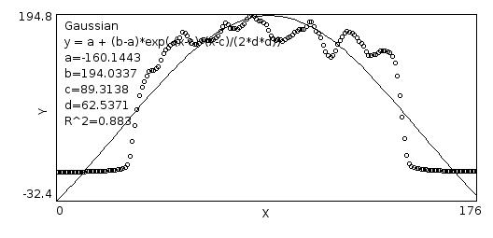Figure 14: A gaussian fit of the profile plot.

Solution 2.6: Point selections
- The number of the following points is decremented by one.
- The selection is saved with the tif-image and can still be modified after the image is loaded again.
- Each click adds a line with measurements to the results table.
- You can get a results-table with the x,y,z(slice)-coordinates as a result:
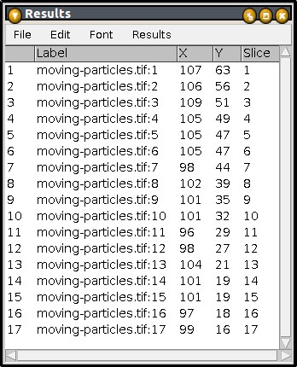Figure 15: Results of a manual particle-tracking.

Solution 2.7: Thresholding and the magic wand tool

  - shortest perimeter: 288.8 pixel
  - longest perimeter: 608.0 pixel
  - shortest diameter: 95.8 pixel
  - longest diameter: 188.4 pixel
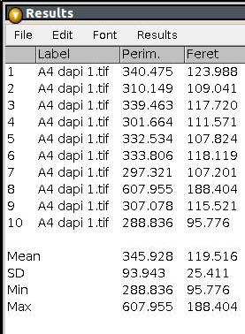Figure 16: Results of the diameter (Feret) and perimeter measurements.
- The complete image has an area of 334750 pixel. For the nuclei I measured an area of 64885 pixel. The percentage of the area covered by nuclei is therefore: 64885p * 100% / 334750p = 19.4%

Solution 2.8: The roi-manager

- It creates an RGB-snapshot of the image with the particle boundaries and labels.
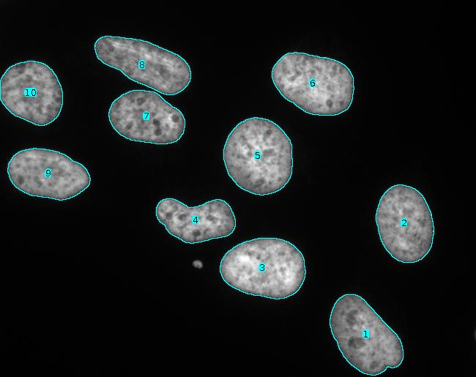Figure 17: Flattened image with particle boundaries and labels from the particles in the roi-manager.
- Create selection creates one single selection containing all nuclei. The split command on the roi-manager splits the selection into selections of connected particles and adds them to the roi-manager.
- The selections in the roi-manager are applied to the active window. This means you have transferred the selections of the nuclei from the dapi-image to the rhod-image. You can now measure the intensities within the nuclei in the rhod-image.
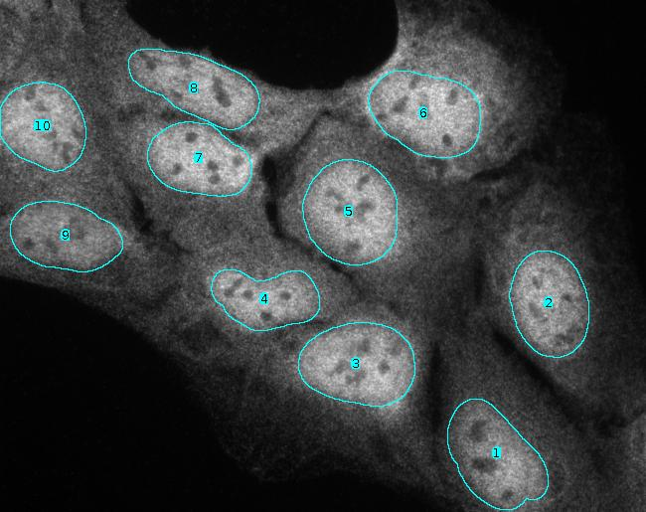Figure 18: The selections of the nuclei on the rhod-image.

Solution 2.9: Measuring objects with the Particle Analyzer

- Objects that are not entirely in the image do not have the correct size and will therefore falsify the measurements of mean or total values that are based on the size (area, diameter, perimeter, etc.). The option exclude on edges allows to ignore these objects.

- 0.7 as a minimum circularity excludes the two nuclei with the lowest circularity values.
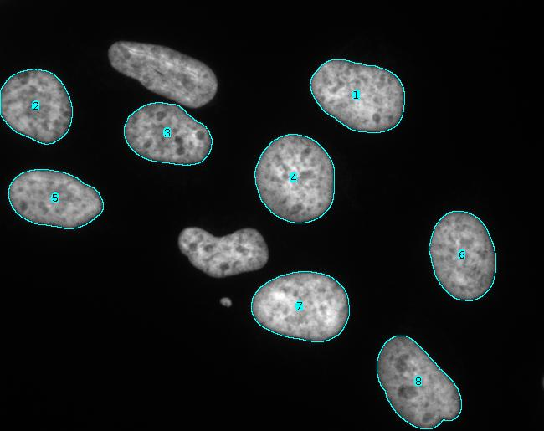Figure 19: The two nuclei with the lowest circularity have been excluded by the particle analyzer.
- With the include holes option only one big particle is found, containing the hole and the inner particle. Without the include hole option the inner and the outer particle are found. Be careful, although measuring with the particle analyzer yields the right results in the second case, the roi added to the roi manager for the outer particle, contains the hole and the inner particle.
- Excluding the blobs touching the edges, I count 46 blobs of all sizes and forms. I measure an average area of 414.5 pixel.

Solution 2.10: Arrows, annotations and overlays
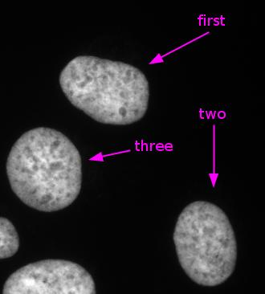Figure 20: Annotations added to the image, using the arrow-tool and the text-tool.

