Requirement Analysis
“Report users per resource”
Accounting project
Montpellier RIO Imaging
03.10.2011

Responsible: Stéphanie Vaudescal
Contact: 04 34 35 95 65 / stephanie.vaudescal@mri.cnrs.fr

Table of Contents
1 Report users per resource 5
1.1 Manager opens accounting tools 5
1.2 Manager chooses parameters in the dialog 5
1.3 Results 6

Illustration Index
figure 1: Accounting report tool main windows 5
figure 2: Report dialog 5

Modifications
Version 0.1 | 03/10/11 | first version

Report users per resource
Reference user: Virginie Georget
Issue: none
A new report is asked, in which a responsible of a platform can obtain for a time interval all users that have been connected to a resource, the start time, the end time, the execution time and the time spend on this resource.

Manager opens accounting tools
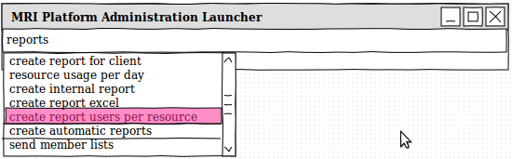figure 1: Accounting report tool main windows
He chooses the new menu item « create report users per resource » cf figure 1

Manager chooses parameters in the dialog
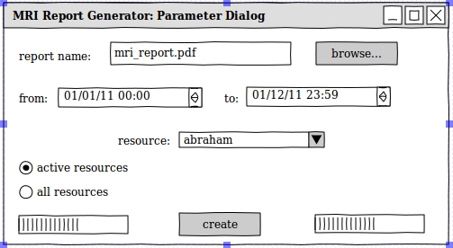figure 2: Report dialog
Parameters are:
  - report name: the name and location of file
  - from-to: Start date and end date of the report
  - resource: allow to specify on which resource the report must be done
  - active resources-all resources: allow to removes old resources in the list of resources

Results
This will result a PDF File containing 2 tables:
  - 1rst table order by start time descendant: manager will be able to know the last person who was connected on the selected resource
  - 2nd table to have the amount of hours and login by user, on the selected resource in the time interval chosen.
Montpellier RIO Imaging
accounting system report for Abraham
06.10.2011 10:00:00

MRI Workstations Activity Report
resource: Abraham
total hours used: 156
FROM 1 janv. 2011 TO 1 oct. 2011

Line | Start time | End time | Execution time | User
1 | 2011-12-01 19:22:38 | 2011-12-01 19:37:38 | 2011-12-01 19:22:31 | georget
2 | 2011-12-01 19:07:38 | 2011-12-01 19:22:38 | 2011-12-01 19:07:44 | georget
... | …
35 | 2011-04-07 16:09:46 | 2011-04-07 16:24:46 | 2011-04-07 11:10:22 | derossi
36 | 2011-04-07 15:54:46 | 2011-04-07 16:09:46 | 2011-04-07 15:55:22 | derossi
37 | 2011-04-07 15:39:46 | 2011-04-07 15:54:46 | 2011-04-07 15:40:22 | derossi
38 | 2011-04-07 15:24:46 | 2011-04-07 15:39:46 | 2011-04-07 15:25:22 | derossi
39 | 2011-04-07 15:09:46 | 2011-04-07 15:24:46 | 2011-04-07 15:10:22 | derossi
... | ...
156 | 2011-02-01 10:54:19 | 2011-02-01 11:09:19 | 2011-02-01 10:54:57 | georget
157 | 2011-02-01 10:39:19 | 2011-02-01 10:54:19 | 2011-02-01 10:39:57 | georget
158 | 2011-02-01 10:24:19 | 2011-02-01 10:39:19 | 2011-02-01 10:24:57 | georget
... | ...

Total per user

User | Hours | Login number
georget | 56 | 19
derossi | 100 | 28
...

